Internship Reflection
Optik Consultancy | May–August 2026

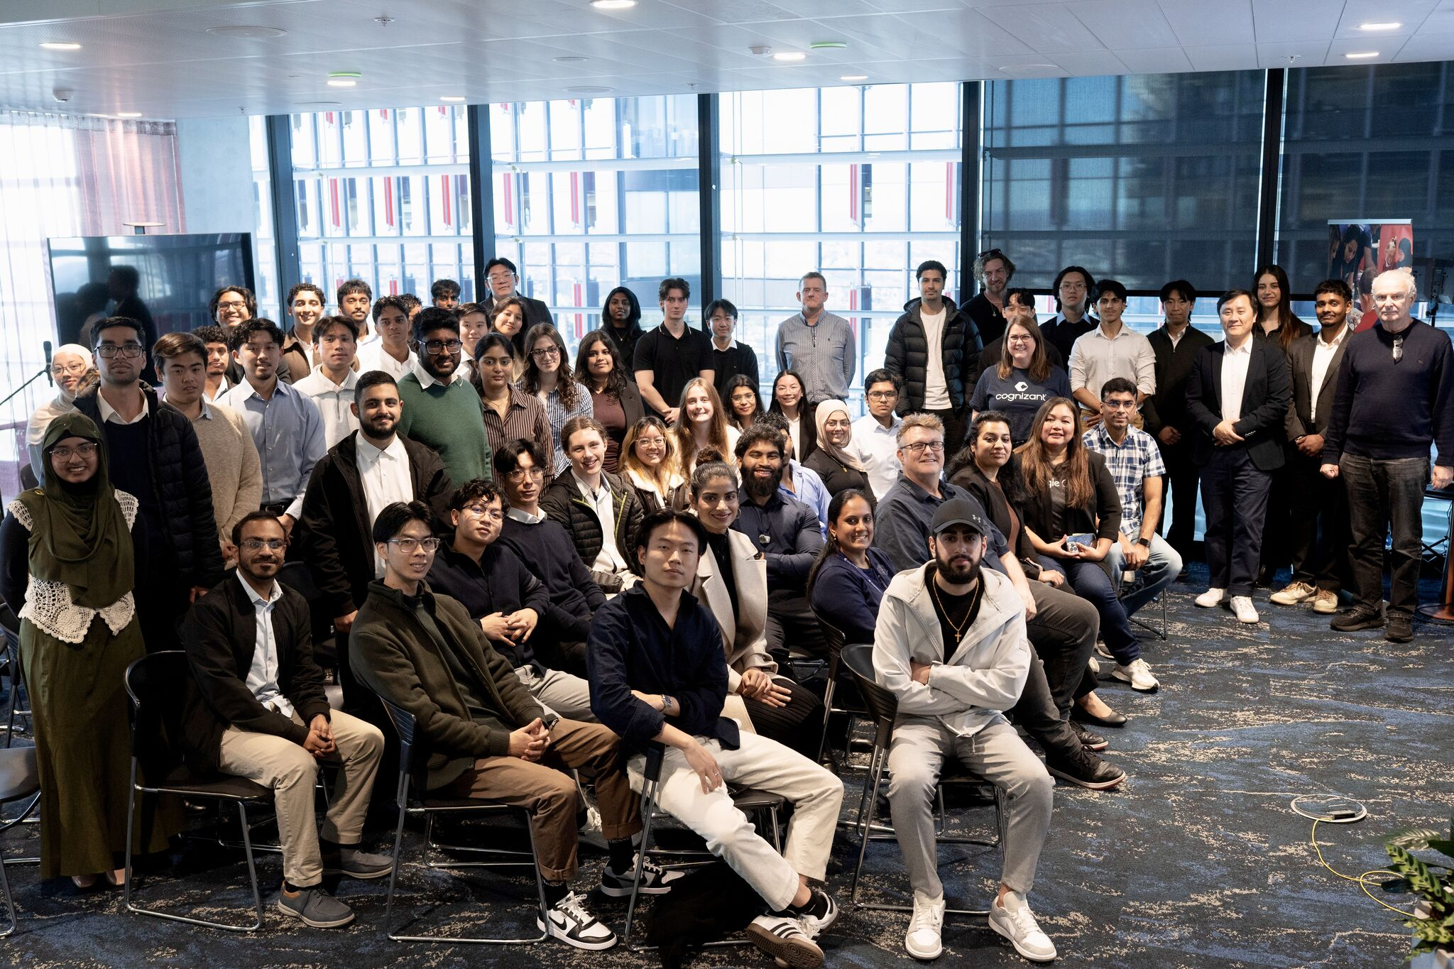
Cognizant Day Out, industry networking day.

What were your expectations about your internship before you joined?
Before joining Optik Consultancy, I expected the internship to be mainly a technical learning experience focused on coding, improving my software engineering skills and contributing to a project under close guidance. I also expected the work to be more structured than university projects, with clearly defined requirements, tasks and processes. My main goal was to understand how software development worked in a professional environment and gain experience I could carry into a graduate role.

What was the reality? How was it different from your expectations?
The reality was much broader. Over the 12 weeks, I worked on a client project for DCPM and took on the role of team lead. Rather than simply receiving tasks, I helped organise the team, communicate progress, work through changing requirements and make decisions when the direction was not always obvious. The project involved developing and testing approaches for identifying and measuring road defects from imagery and video, then preparing the solution for client handover. I was exposed to technical work, client meetings, documentation, presentations and collaboration across different disciplines. The internship also included workshops, networking activities and a hackathon, giving me experience well beyond the purely technical placement I had expected.

What lessons were the most important from your internship? Why were they important?
The most important lesson was that being effective in software engineering requires much more than technical ability. Leadership was not about having every answer; it was about keeping people aligned, listening to different perspectives, following up on work and creating an environment where the team could contribute. I also learned the importance of adapting when an approach does not work. During the road-defect project, we tested ideas that did not provide an effective path forward, recognised their limitations and changed direction rather than becoming attached to an initial solution. These experiences improved my confidence in problem-solving, communication and taking responsibility for outcomes.

After your workplace experience, what would you say your value proposition would be to an employer? How can you demonstrate this?
I can offer employers a combination of technical problem-solving, communication, teamwork and developing leadership experience. I am comfortable learning new tools, working through unfamiliar problems and explaining technical ideas to people with different backgrounds. I demonstrated this by leading the DCPM project team, contributing to client communication and handover activities, and working collaboratively throughout the internship. I also took part in an industry hackathon, where my team developed CarbonLens and won the competition. Together, these experiences show that I can contribute effectively in both structured project work and fast-paced team environments.

How did your internship influence the type of role in which you are interested?
The internship changed how I think about the type of role I want after graduating. While I remain interested in software engineering, I now feel that a consulting environment would suit me particularly well. I particularly enjoyed working directly with a client on a unique problem, understanding their needs and limitations, and helping develop a solution that was practical for their situation. I found the process of balancing technical possibilities with client expectations and real-world constraints especially rewarding. In the future, I would like to work in a consulting or client-facing software engineering role where I can continue developing my technical skills while solving varied problems, working closely with different stakeholders and gradually taking on more responsibility and leadership.

Internship Highlights
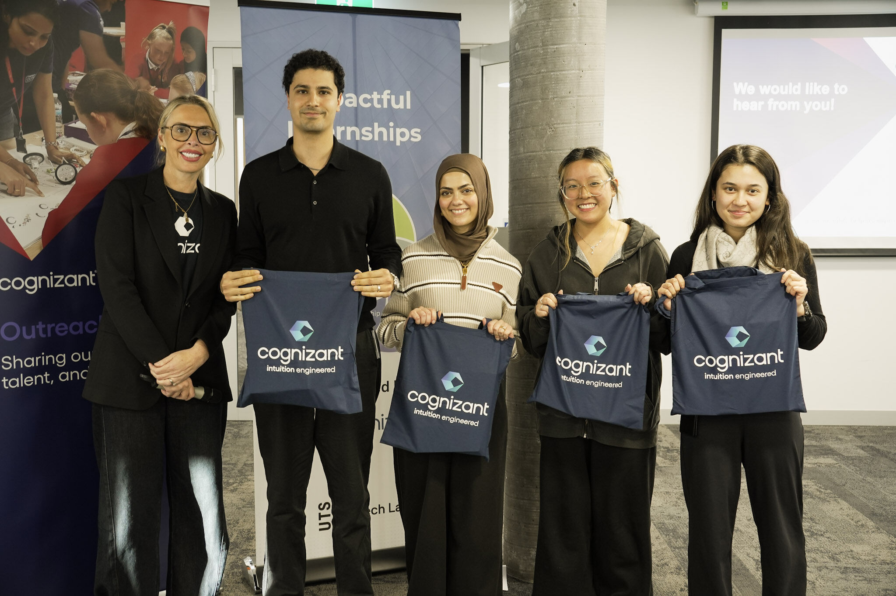  AWS Kiro hackathon win. | 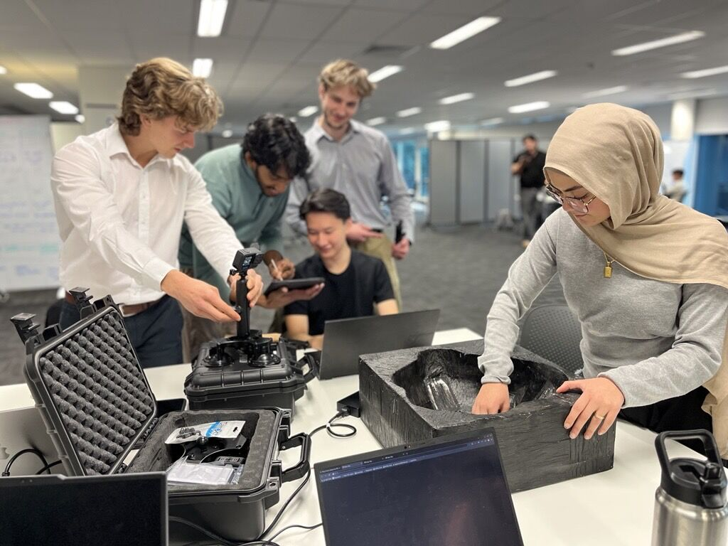  Hands-on project work with the team.

